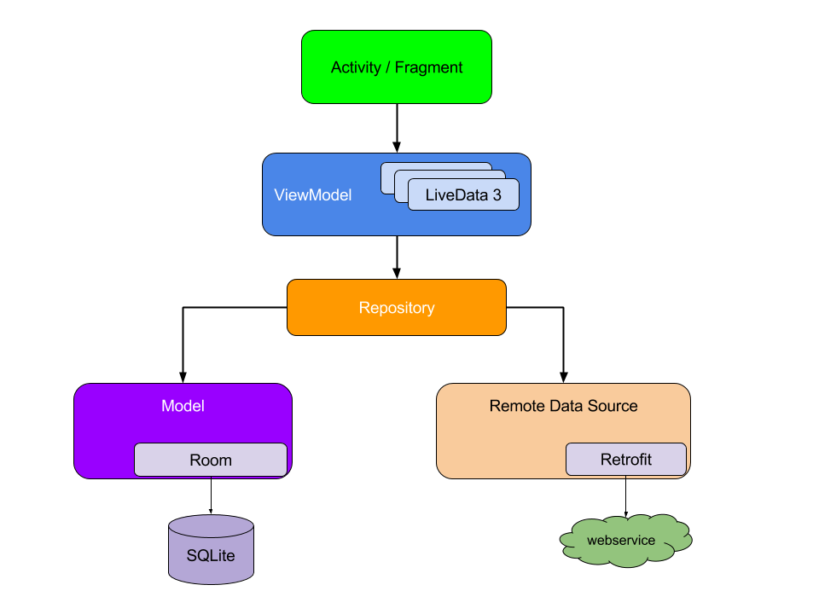

Notice that each component depends only on the component one level below it. For example, activities and fragments depend only on a view model. The repository is the only class that depends on multiple other classes; in this example, the repository depends on a persistent data model and a remote backend data source.

A **ViewModel** object provides the data for a specific UI component, such as a fragment or activity, and contains data-handling business logic to communicate with the model. For example, the ViewModel can call other components to load the data, and it can forward user requests to modify the data. The ViewModel doesn't know about UI components, so it isn't affected by configuration changes, such as recreating an activity when rotating the device.